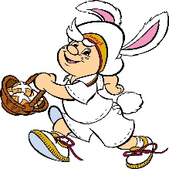
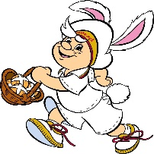
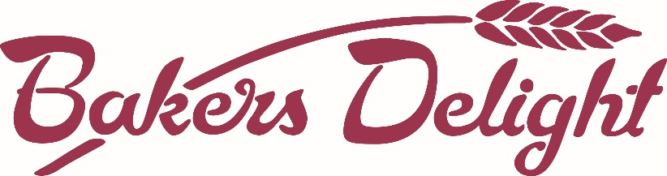
HOT CROSS BUN ORDER FORM

Bakers Delight Croydon would like to offer you the opportunity to purchase delicious Hot Cross Buns and make a profit for your Kinder. The more buns you purchase the more profit you make.

For every 6 pack of Hot Cross Buns you order, Bakers Delight Croydon will give $2 to the Kinder.

Simply fill in the details below and select which Hot Cross Buns you would like to order, bring your order form together with full payment back to Kinder by Friday, 18th March 2016 . Please put the order form and payment in the reception/fee box near the entrance of the kinder. Your delicious hot cross buns will be ready to collect on Thursday, 24th March 2016

Remember to ask family and friends if they would like to order some too.

Student’s Full Name:______________________________________ Class:_______________________

Contact Name:_______________ Contact Number:_______________

Name | Traditional  Hot Cross Buns  Qty (per 6 pack)  $7.00 per 6 pack | Choc Chip  Hot Cross Buns  Qty (per 6 pack)  $7.00 per 6 pack | Mocha  Hot Cross Buns  Qty (per 6 pack)  $7.00 per 6 pack | Fruitless  Hot Cross Buns  Qty (per 6 pack)  $7.00 per 6 pack | Total $ | Paid

